AWS Basic Different Services
Lab Book




Document Revision History

Date | Revision No. | Author | Summary of Changes
May 2018 | 1.0 | Tanmaya K Acharya | Created As per TOC

Table of Contents
Document Revision History 2
Table of Contents 3
Getting Started 4
Overview 4
Setup Checklist for AWS Services 4
Instructions 4
Lab 1. Create an EC2 instance with root volume 5
Lab 2. AWS Storage Service (S3 and EBS ) 16
Lab 3. AWS Database Service (RDS) 17
Lab 4 : Monitoring service 18
4.1: Attach Amazon Cloudwatch service to your EC2 instance 18
Lab 5 . IAM Service 19
Lab 6 Networking service (VPC , subnetmask , Elastic IP , Internet gateway) 24
Lab 7 Computing service (ELB and AutoScaling) 27
Appendix A: Table of Figures 27

Getting Started

Overview
This lab book is a guided tour for learning AWS Basic Different Services. It comprises scenario based applications and ‘To Do’ assignments. Flow diagrams and screen snap shots are provided where necessary.

Setup Checklist for AWS Services
Here is what is expected on your machine in order for the lab to work.
Minimum System Requirements
- Intel Pentium 90 or higher (P166 recommended)
- Microsoft Windows 95, 98, or NT 4.0, 2k, XP
- Memory: 32MB of RAM (64MB or more recommended)
- Internet Explorer 11.0 or higher
- Internet connection

Please ensure that the following is done:
- A fast internet connection
- Eclipse with Tomcat8 server in your system
- Puttygen.exe and putty.exe file should be available
- WinScp file for Data transfer
- AWS Account login credential
- JackDB Account credential

Instructions

- Create an AWS account.
- Before start the lab exercises Sign in to AWS account.
- You may also look up the on-line docs on AWS site.

- Create an EC2 instance with root volume

Goals | - Create EC2 instance and deploy a web application on your instance by using tomcat server on your instance
Time | 1.30 Hours

  - Creating EC2 instance On Linux server

Step 1: Sign in with aws account to see the AWS home page and Select
EC2 service under Compute Section

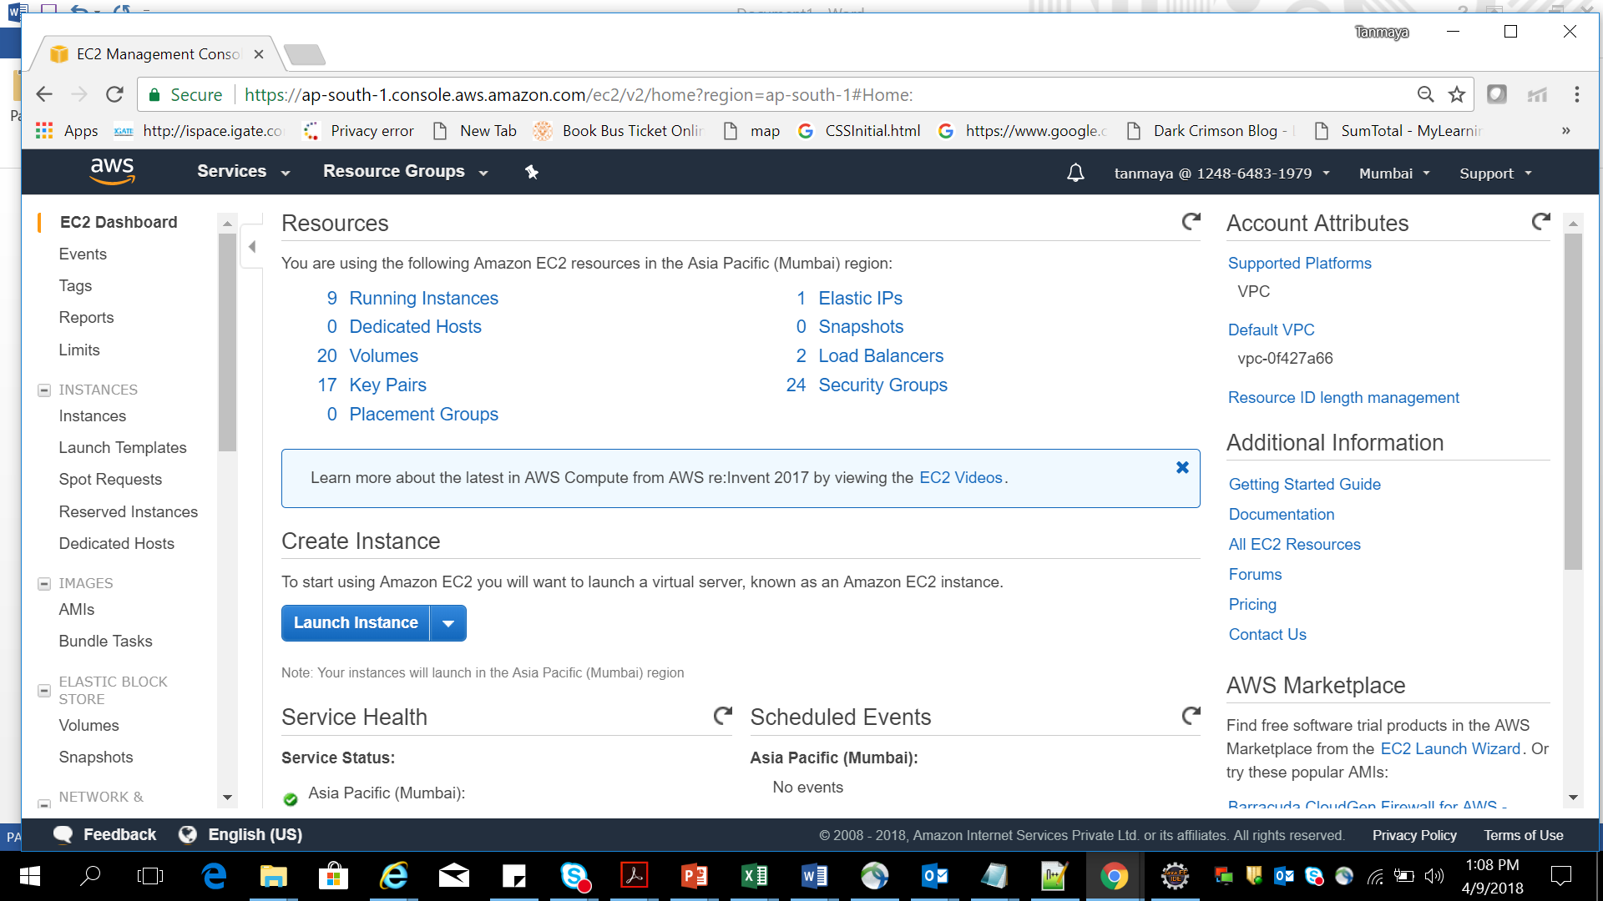

Figure 1: EC2 Dashboard

Step 2 : Now click on Launch Instance button and select the “Free tier only” check box .

Step 3 : Choose Amazon Linux AMI 2017.09.1(HVM), SSD Volume Type

Step 4 : Choose an instance type – t2.micro and click on next

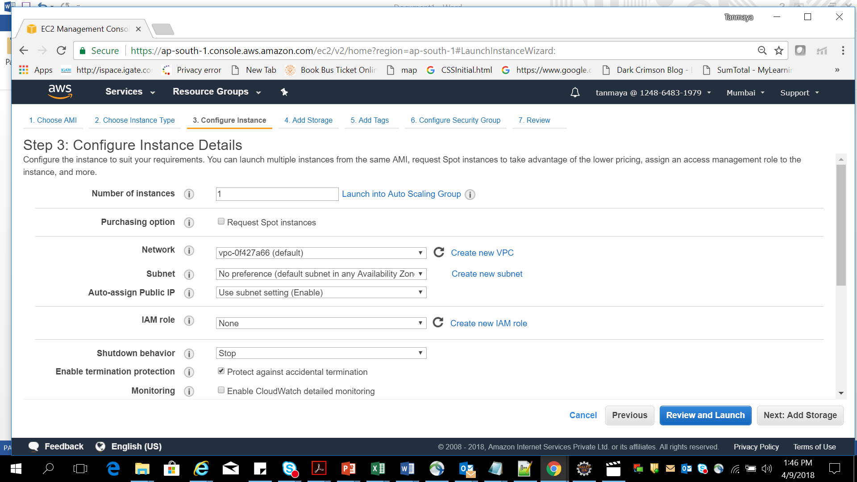

Figure 2: Configuration instance

Step 5 : Click on Next: Add Storage button .

Step 6: Choose Storage type - Magnetic and choose Next : Add tags button

Step 7 : Add the different tags (Key value) .

Step 8 : Now click on Next : Configure Security groups . Choose the New security
Group and provide the details i.e. name, description etc.

Step 9: Add different rules as per the traffic you want to access your account(optional)

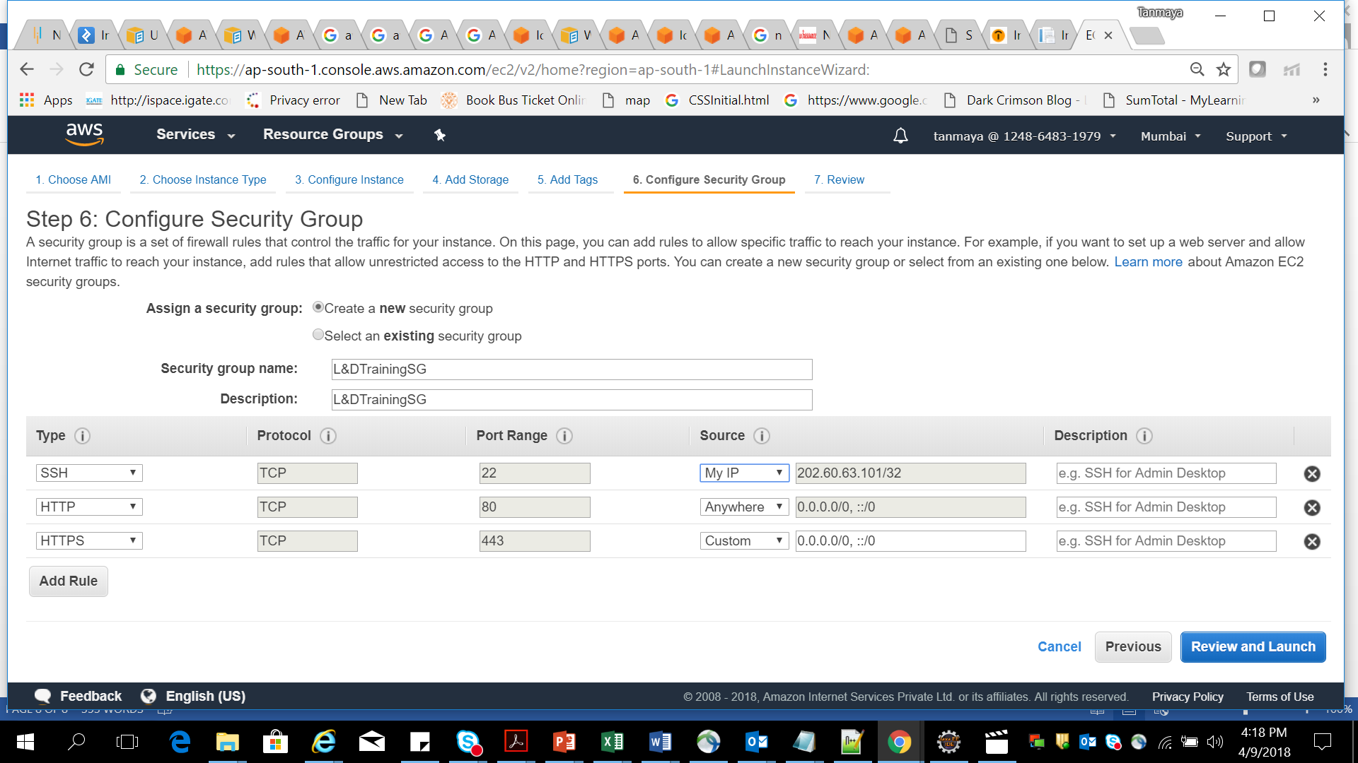

Figure 3: Security group

Step 10 : Click on Review and Launch button

Step 11 : Click on Launch button

Step 12 : Provide a key pair name and Download Key Pair into “d:\SW\” drive.
After that launch instance button.

Step 13 : Now see the instances from EC2 dashboard and see the instance .

Step 14 : Click on the instance to see the details

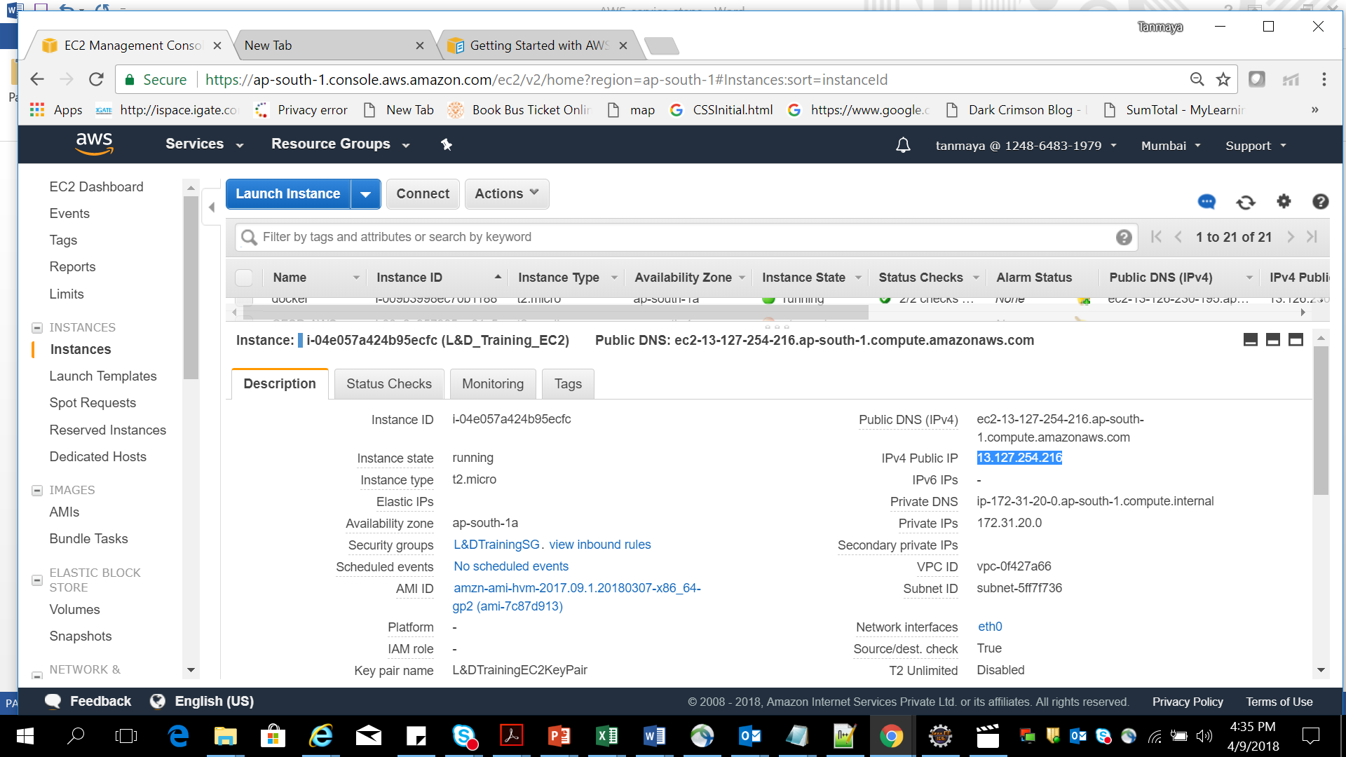

Public IP address used to access resource
Figure 4: EC2 instance detail
  - Steps to run a tomcat with Sample Helloworld application in EC2 instance

Step 1 : Download the 64bit of putty.exe and puttygen.exe

Step 2 -- Right click on putty.exe file, puttygen.exe and save it to a drive

Step 3 -- Now run your puttygen and then click on load button to load the .pem file

Step 4 : Then it will be successfully imported

Step 5 : Now click on ok and click on save private key button.

Step 6 : Click on yes button
Step 7 : Then choose the .pem file and change the ext to .ppk . Click on save button.

Step 8 : Now Open Putty.exe file .

Step 9 : Type the host name : ec2-user@<<public IP address>>

Step 10 : Expand SSH section on left pane and select the “Auth “ submenu.

Step 11 : And browse the private key .ppk

Step 12 : Now click on session on left pane

Step 13 : copy the host name to saved sessions .

Step 14 : Then click on save button on right

Step 15 : Now again select your session in saved session text area , click on Load and then click on open button

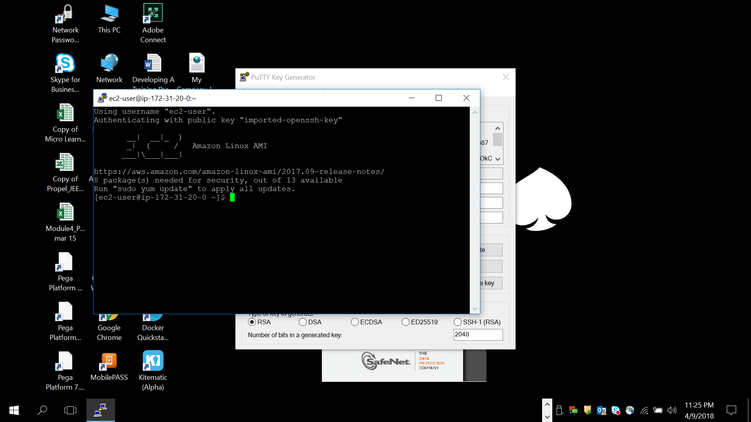

Figure 5: Command prompt for EC2 Linux instance
Step 16 : Type the command “Sudo /usr/sbin/alternatives –config javac“ <<enter>>
Step 17 : Type “java -version” command <<enter>>
Step 18 : Type command “yum list tomcat*” <<enter>>
Step 19 : Type command “sudo yum install tomcat8” <<enter>>

Step 20 : Type “y” <<enter>>
Step 21 : Type command “sudo yum install tomcat8-admin-webapps” <<enter>>
Step 22 : say “y” and enter

Step 23 : Type command “sudo service tomcat8 start” <<enter>>

Step 24 : Go to EC2 instance and open the port 8080

Step 25 : Copy the public DNS of your instance .
Step 26 : Open the browser and Type the URL : - <Public dns>:8080/manager/html

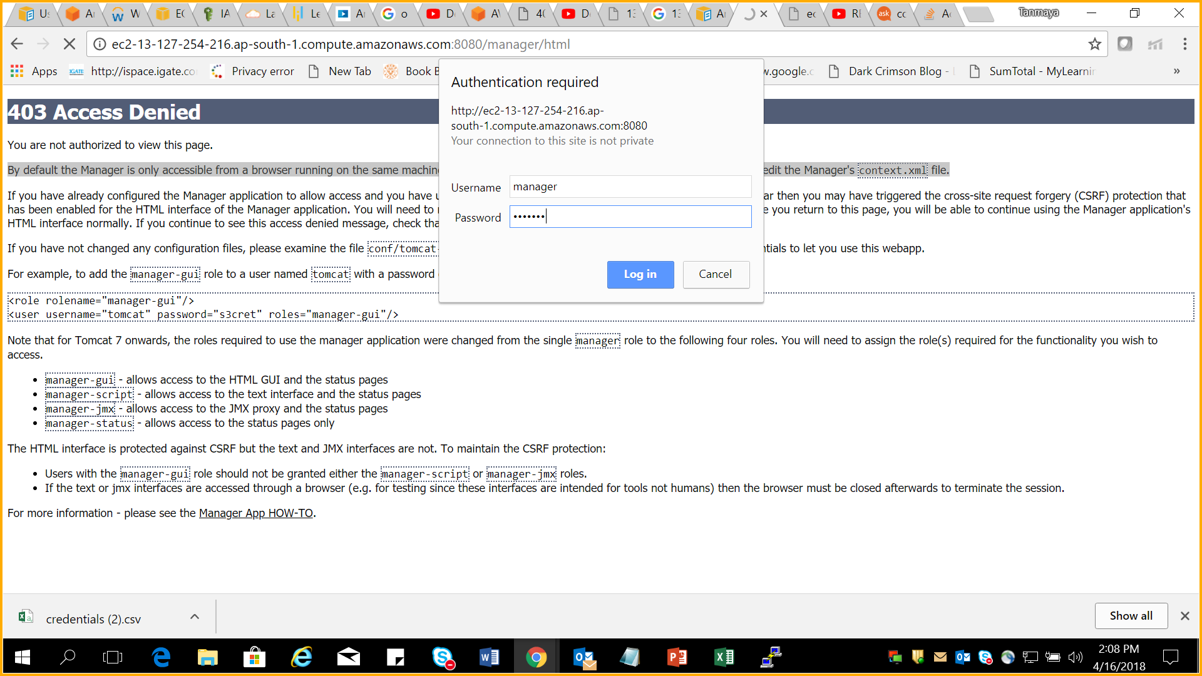

Figure 6: EC2 Instance Tomcat server page
If this Authentication Prompt is not shown and you get 403 access Denied error Follow below steps otherwise directly jump to Step 35 .

Step 27 : Type command “Cd conf” <<enter>>
Step 28 : Type command “ls” <<enter>>
Step 29 : Type command “cd Catalina” <<enter>>
Step 30 : Type command “cd localhost” <<enter>>
Step 31 : Type command “ls” <<enter>>

If there is no file i.e. manager.xml available in localhost then create it

Step 31 : Type command “sudo vi manager.xml” <<enter>>
Step 32 : Type the below element in that file

<Context privileged="true" antiResourceLocking="false"
docBase="${catalina.home}/webapps/manager">
<Valve className="org.apache.catalina.valves.RemoteAddrValve" allow="^.*$" />
</Context>

Step 33 : Press Escape key and type “ :wq!” (save and exit)
Step 34 : Type command “sudo service tomcat8 restart” <<enter>>

Step 35 : Now go back to tomcat8 location
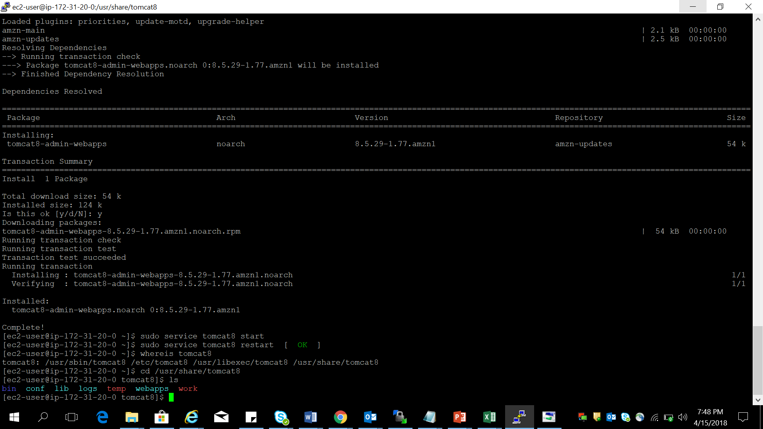

Figure 7: putty.exe prompt
Step 36 : Type command “cd conf” <<enter>>
Step 37 : Type command “ls” <<enter>>
Step 38 : Type command “sudo vi tomcat-users.xml” <<enter>>(edit this file)

Step 39 : Press “o” key from keyboard and enter few elements
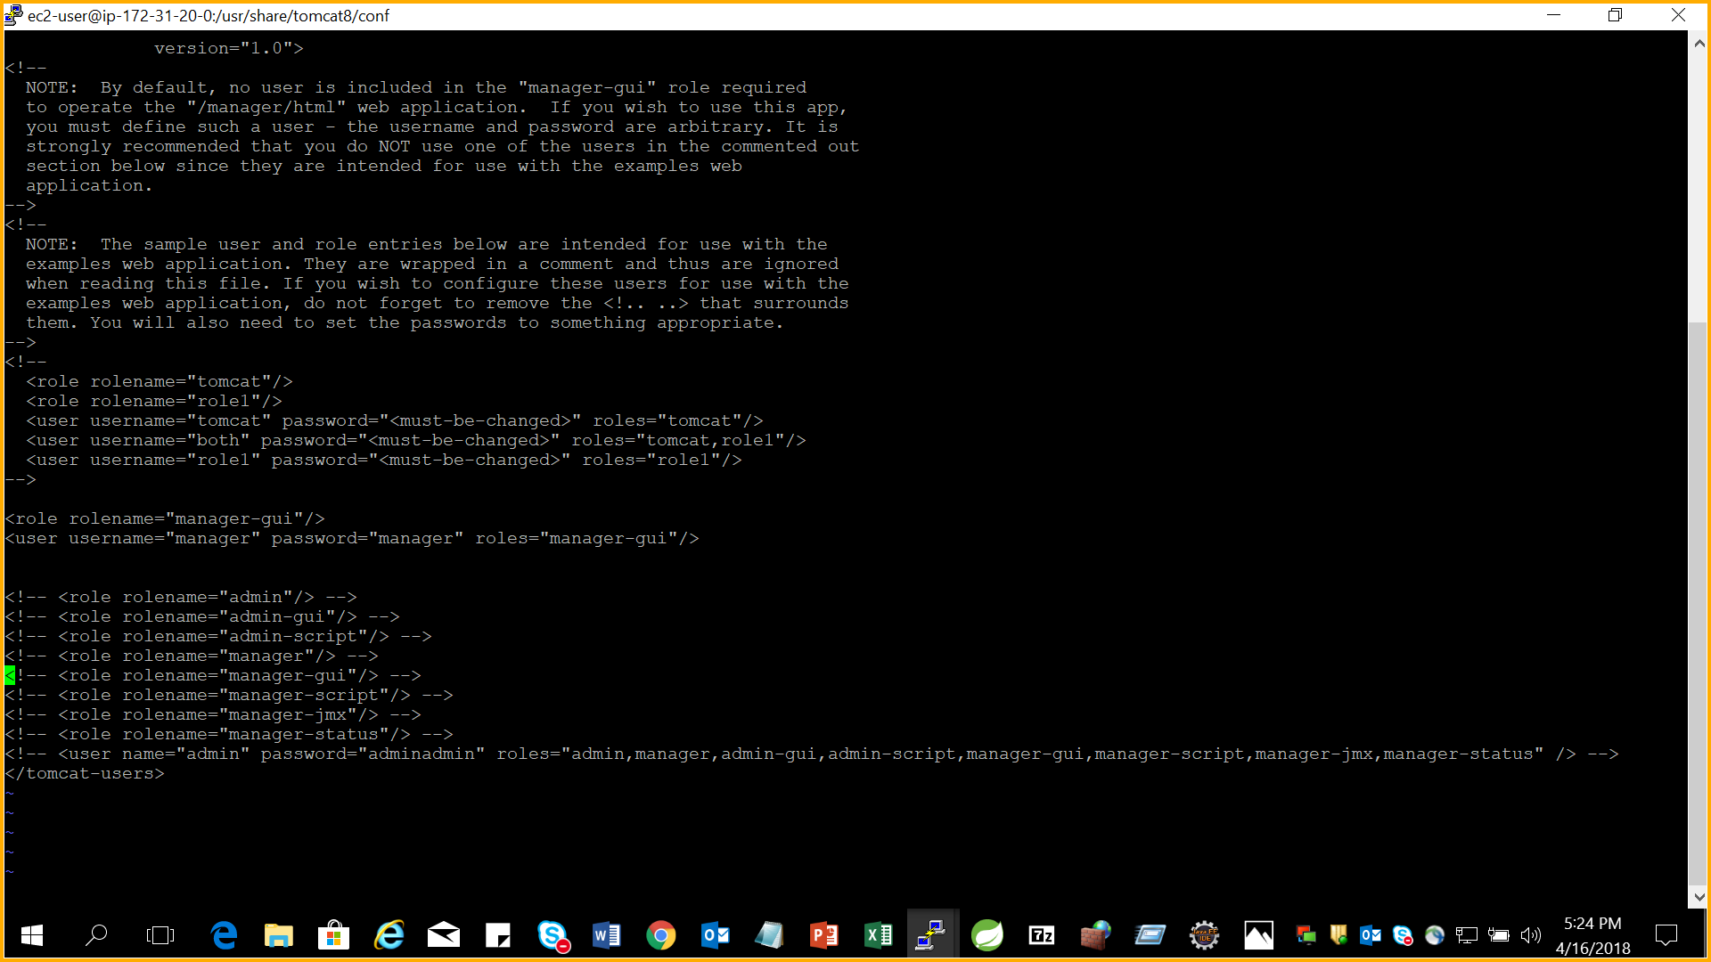

Figure 8: Tomcat-user.xml
Step 39 : Now save this file.

Step 40 : Go to the browser and enter the URL

Step 41 : Enter user – manager and password - manager <<login>>

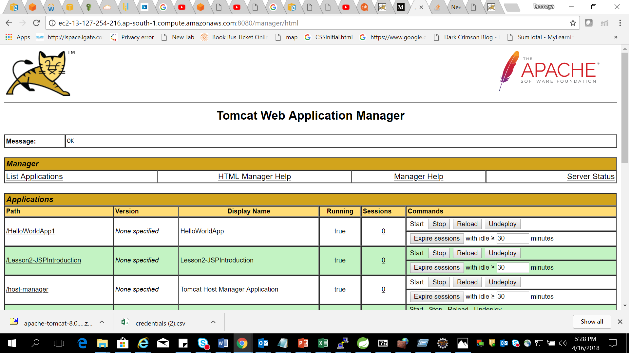

Figure 9: EC2 Tomcat page
Step 42: Now develop a Helloworld application in your system by using Java7 and tomcat8 .Run it and test your app.

Step 43 : export war file to a location.

Step 44 : scroll down the browser and click on deploy war file button.

Step 45 : Now click on the application link and see the output .

1.3 Create an Amazon EC2 Instance(name- LnDJavaLab1) and run a tomcat with Sample Hello World application.

Lab 2. AWS Storage Service (S3 and EBS )

Goals | - Create a S3 Bucket and host a static web page  - Create EBS volume and attach to existing EC2 instance
Time | 1.0 hr.
Pre-requisite | - AWS Account should be ready  - Create a index.html page with form interface

2.1 Create a S3 bucket and Host a standalone HTML web site in S3 bucket which is public access and browse on internet)

2.2 Create an EBS Volume and attach to the existing EC2 instance and mount this secondary volume to store data.

Lab 3. AWS Database Service (RDS)

Goals | - Create a MySQL instance in AWS RDS and use the MySQL DB by using JackDB interface
Time | 1.0 hr
Pre-requisite | - Basic MySQL query knowledge (Create table, insert command etc.)  - AWS account and JackDB Account to be ready

3.1 Do the following task
- Create a MySQL type DB instance in AWS RDS .
- Login to JackDB Account for query interface
- Use jackDB MySQL type and configure as per AWS RDS DB type
- Use The JackDB interface to Create a table Employee with columns (empId , name , salary)
- Use DML operation (insert ,update, delete query ) to your table
- Drop the table

Lab 4 : Monitoring service

Goals | - Amazon Cloudwatch Monitoring for EC2 instance
Time | 0.45 hours

4.1: Attach Amazon Cloudwatch service to your EC2 instance
Create an EC2 instance and use the Amazon Cloudwatch monitoring service to monitor the load on EC2 instance . Once the load will be more set an alarm and send the notification to user.

Lab 5 . IAM Service

Goals | - Create a user credentials and provide only read access permission to one EC2 instance to that user
Time | 1 Hours

5.1. Create an EC2 instance.

Follow the Steps to create a user by using IAM service

Step 1: Choose the IAM service in AWS

Step 2 : Click on User link in IAM dashboard and click on AddUser button

Step 3 : Type a user name and choose both the access type

Step 4 : Select custom password and provide a password .( it must contain at least 12 characters and it must contain a digit )
Step 5 : click on Next permission button.

Step 6 : Click on Attach existing ploicy button directly
Step 7 : Select AmazonEC2ReadonlyAccess checkbox from existing list and click Next:review button.

Step 8 : click on create user button .
Step 9 : Now download the credential in .csv format and click on close button.
Step 10 : Click on user link and review the policy.

Follow the Steps to create a policy for your Ec2 instance which you have created before.
Step 11 : Click on Policy link in IAM dashboard
Step 12 : Click on createpolicy button
Step 13 : Choose EC2 service.
Step 14 : Click on Select action link and choose List and read checkbox
Step 15 : Select resources and choose specific option
Step 16 : Click on Add ARN link

Step 17 : click on Add button
Step 18 : click on review policy button
Step 19 : click on Add permission link
Step 20 : choose IAM service
Step 21 : select Action and expand Write option
Step 22 : choose checkbox “Update Login Profile”
Step 23 : Now choose specific resources and add ARN

Step 24 : Click on review policy button
Step 25 : click on create policy button
Step 26 : go to user and select the user you created before
Step 27 : detach the previous policy
Step 28 : Add the policy you created before

Step 29: click on Next review button
Step 30 : check the new policy attached to user

Steps to allow the user top signin and see the restrictions

Step 31 : Go to browser and add the user name and password and login
Step 32 : Select EC2 service and see all the instances.
Step 33 : Choose your instance and try to stop it.

5.2: IAM Service implementation
Create an EC2 instance .Create a low privilege user(name – Jack ) in IAM and provide the ReadOnly permission to that EC2 instance. User should login in different console and see the limited privileges to that EC2 instance.

Lab 6 Networking service (VPC, subnet mask, Elastic IP, Internet gateway)

Goals | - Create a Custom VPC  - Create an Elastic IP  - Create Subnet mask  - Create Internet gateway
Time | 2.0 Hours

6.1: AWS Networking Service implementation
Create a Custom AWS VPC With Private , Public Subnet , Elastic IP address , Internet gateway and Custom Route table. Ensure that the EC2 instance created inside your Custom VPC will be receiving Internet traffic .

Lab 7 Computing service (ELB and AutoScaling)

Goals | - Create a ELB in your Custom VPC  - Create a Auto Scaling on EC2 instances in your VPC
Time | 2.0 Hours

6.1 Follow the Steps to Create a Elastic Load balance in Custom VPC

Before you start the Load balancer in your VPC you must have two public subnet in different AZ . If not follow the steps

Step 2 : Go to Subnet in VPC dashboard and click on Create subnet button

Step 3 : Provide the details in dialog box and click on “Yes create” button

Step 4 : Now select the subnet you created and click on Route table tab at bottom

Step 5 : Now edit the rout table and attach the custom route table you created before having public subnet.

Step 6: Now go to Route table from Dashboard , select the custom route table and check the subnet section

Step 7: More than 1 public subnet should be available in your custom route table.

Step 8 : Now go back to EC2 dashboard and launch a new EC2 instance.

Step 9 : In configure instance page choose the custom VPC and choose the public subnet you created before. Then make auto assign Public IP enable and select the
“enable termination protection” on.

Step 10 : Now click next and follow the steps to create the instance

Step 11 : Once the instance created , select it in view section

Step 12 : Click on Action and choose create image option

Step 13 : Provide the details and create an AMI of your instance.

Step 14 : Now choose the Load balancer from Dashboard and click on Create
Load balancer button

Step 15 : Choose Application Load balancer and click on Create button

Step 16 : Provide the Name and in Advanced section , choose your VPC and select
all Public subnet

Step 17 : In configure routing page , provide the Target group

Step 18 : go to Advanced health check settings

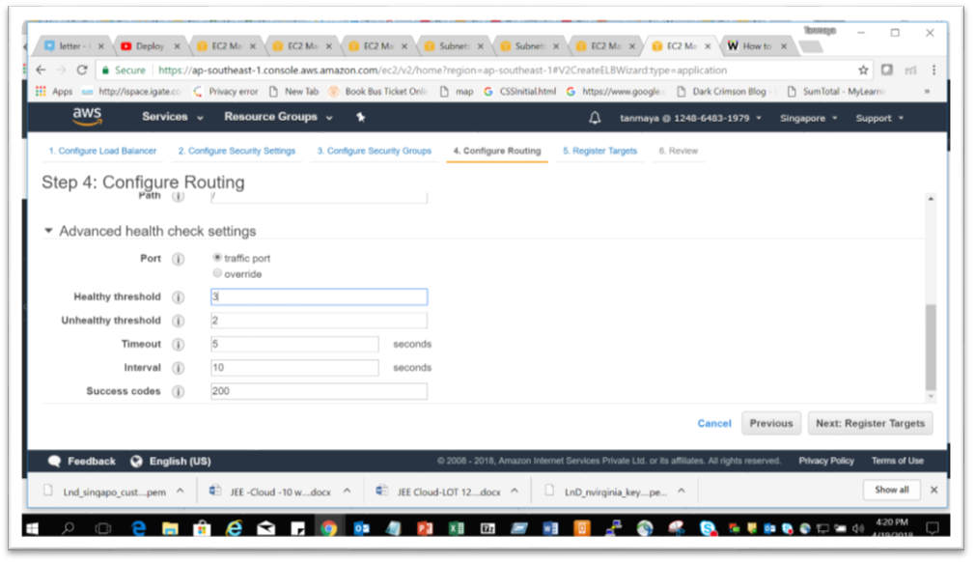

Figure 10 : Configure Routing page
Step 19 : click on next

Step 20 : Select target group ,Scroll down , select your EC2 instance and click
on register

Step 21 : Click on create button .

Follow the Steps for Auto Scaling on your instance

Step 22 : Click on launch configuration

Step 23: Click on My AMIs and Select your AMI , you created before and click on Launch

Step 24 : Click on next

Step 25 : In the configure detail page provide the name and under Advanced details
Choose the radio button “ Assign a public IP address to everyone”

Step 26 : Click on next button and finally create.

Step 27 : Create Auto scaling group from this launch configuration

Step 28 : Choose the custom VPC and apply all public subnet

Step 29 : Under Advanced details follow it

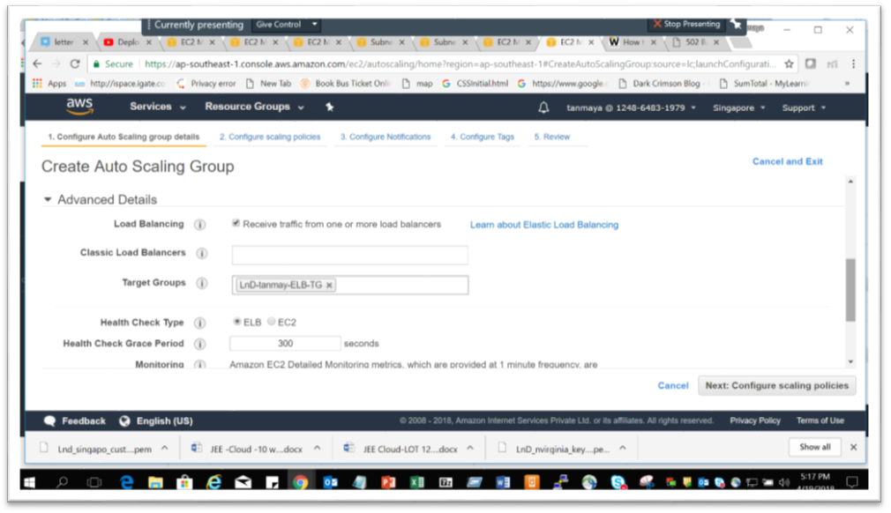

Figure 11 : Configure AutoScaling page
Step 30 : Click on Next

Step 31 : Don’t apply any notification and click on Next

Step 32 : Now Add gthe tag and click on create button

Step 33 : Now go to your instances and see your EC2 instance created in your VPC public subnet and the Ato scalling tag name for your instance.

Step 34 : Now apply the load on your instance ang check the behavior of Autoscalling

6.2 Create Autoscaling group and implement it by increasing load
in your EC2 instance

Appendix A: Table of Figures

Table of Figures

Figure 1: EC2 Dashboard 5
Figure 2: Configuration instance 6
Figure 3: Security group 7
Figure 4: EC2 instance detail 8
Figure 5: Command prompt for EC2 Linux instance 9
Figure 6: EC2 Instance Tomcat server page 10
Figure 7: putty.exe prompt 11
Figure 8: Tomcat-user.xml 12
Figure 9: EC2 Tomcat page 13
Figure 10 : Configure Routing page 24
Figure 11 : Configure AutoScaling page 25

